

**AI in the Music Industry: A Disruptor to Fight, Ignore, or Embrace?**

***Sonarworks CEO Helmuts Bems presents research-driven insights to spark industry discussion on AI in music production***

***San Francisco, CA, March 26, 2025* – The role of AI in the music industry has sparked widespread debate following recent reports of platforms like Spotify increasingly integrating AI-generated content. Is this just a fleeting trend, or the beginning of a transformative shift in music creation? Helmuts Bems, CEO of** [**Sonarworks**](https://www.sonarworks.com/)**, dives into the impact of AI on music production in an** [**insightful report**](https://www.sonarworks.com/blog/research/ceo-keynote-ai-in-the-music-industry-2025) **that provides a comprehensive framework for understanding its potential.**

**The Context: Disruptive Change on the Horizon**In 2024, multiple reports indicated that Spotify is increasingly incorporating AI-generated content from AI-generated DJs to AI-powered playlists. Is this merely clickbait, or is this the beginning of a much larger disruption? Bems brings insights from over 100 interviews with industry professionals, including CEOs, Grammy-winning engineers, and casual music listeners. The conversation around AI’s role in music production is already underway.

U.S Recorded Music Revenues by Format

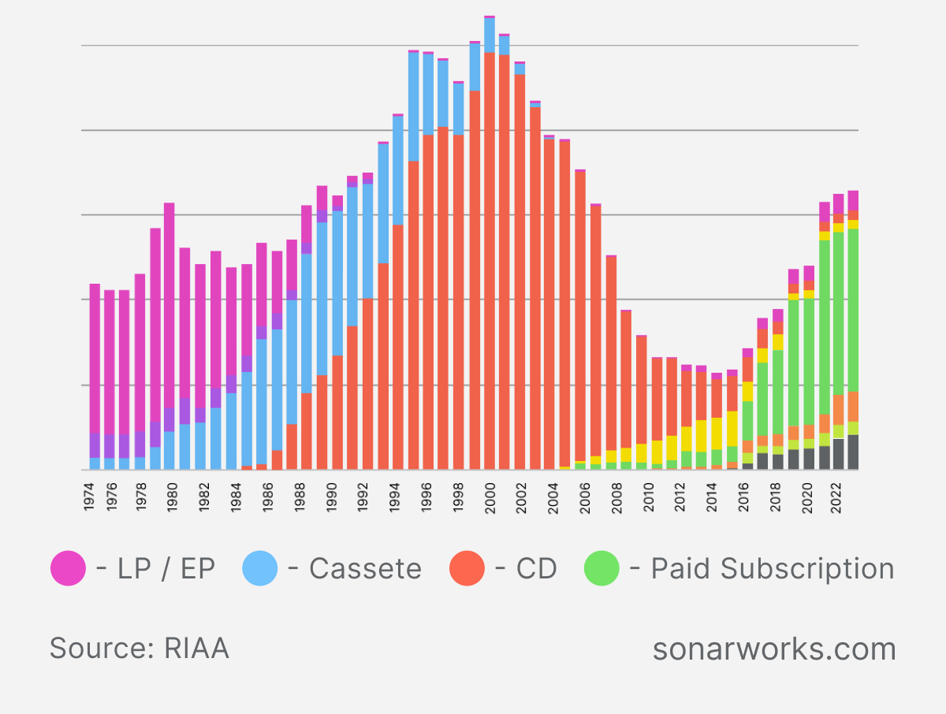

AI Growth is Unstoppable

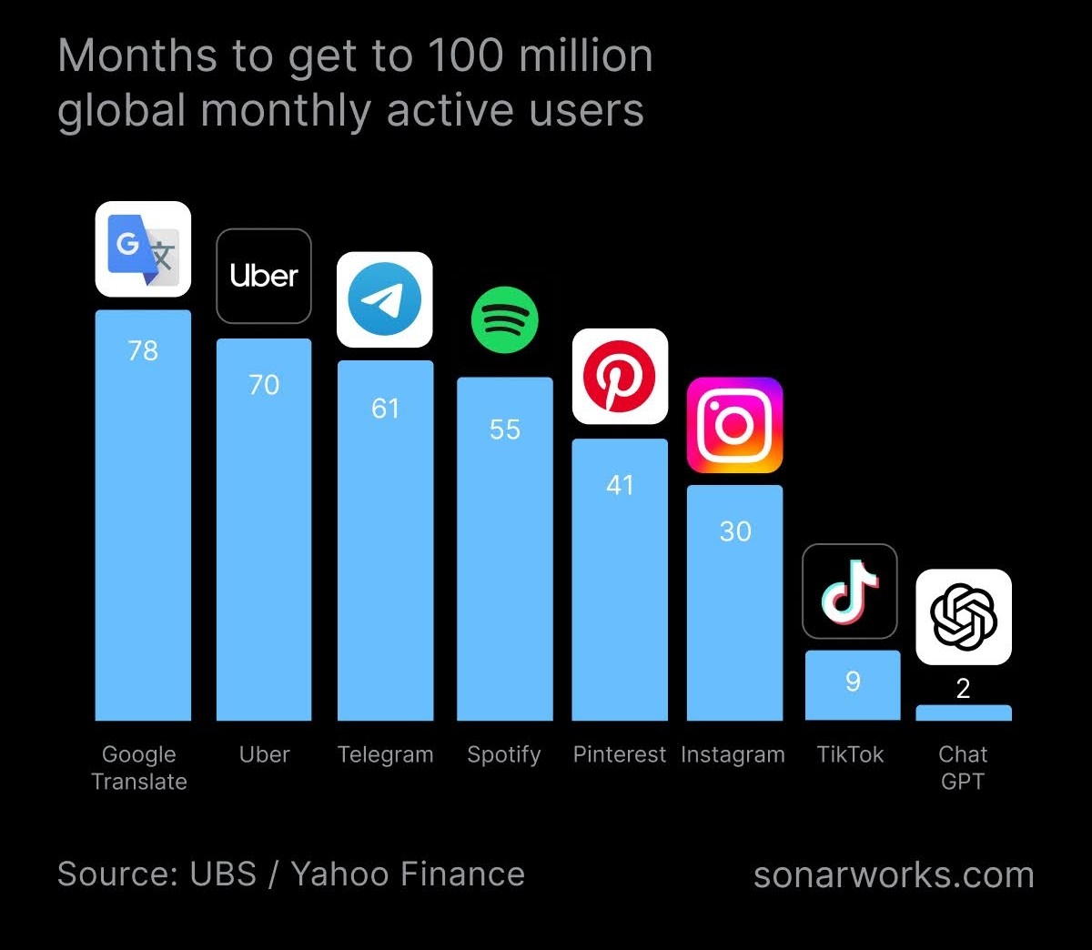

Since 2022, Sonarworks has been exploring how AI will impact the music industry, and this article is a direct result of those ongoing discussions. The ultimate goal is to spark a broader conversation and gather feedback on how the music industry can best prepare for an AI-driven future. Bems invites those across the music industry, from labels and producers to artists and streaming audiences, to share their insights on the topic by commenting on this [LinkedIn post](https://www.linkedin.com/feed/update/urn:li:activity:7310645945430372352).

**A Historical Lens: The Music Industry’s Cyclical Nature**The music industry has seen multiple waves of disruption, with revenues shifting dramatically every decade. From the decline of CD sales to the rise of streaming, the industry has experienced seismic shifts. AI, with its unprecedented speed of adoption, seems primed to be the next big disruptor. As AI technology evolves rapidly—outpacing the adoption rates of platforms like TikTok and Instagram—it is clear that the industry is on the brink of another major transformation.

**What’s at Stake: AI’s Role in Music Production**AI has the potential to disrupt multiple aspects of the music industry, including:

* **Music Production**: How music is composed, recorded, mixed, and mastered.
* **Distribution**: How content reaches listeners.
* **Live Shows**: The future of performances and AI-generated live content.
* **Copyrights**: The economic and legal impacts on royalties and ownership.

**AI Framework for Music Creation**Music creation has traditionally been human-driven, however, in the AI era, three new modes of production are emerging:

1. **AI-Assisted**: Humans use AI tools to enhance the production process (e.g., AI mixing, mastering, and sound effects).
2. **AI-Generated**: Full music compositions created entirely by AI based on human prompts.
3. **Real-Time AI-Generated**: Music dynamically created by AI in real-time, tailored to the listener’s environment or mood.

This new framework opens the door to possibilities such as adaptive music based on real-time events, or even AI-generated music for live performances.

**Three Scenarios for the Future**Through interviews and expert input, Sonarworks has modeled three potential scenarios for the future of AI in music production:

* **Slow Disruption**: AI gradually takes over music creation over the next 10 years, with AI-generated content surpassing human-generated content.
* **Fast Disruption**: Rapid technological advancements push AI-generated music to overtake human content in just 5 years.
* **No Disruption**: Backlash from legal and social barriers slows or halts AI’s advancement in music.

Each scenario presents its own opportunities and risks for creators, labels, streaming platforms, and listeners.

**AI’s Impact Across the Industry**AI will leave no corner of the music industry untouched — whether it's producers crafting hits, labels navigating copyrights, software developers building next-gen production tools, or musicians and streaming platforms redefining their roles.

Looking ahead, the rapid adoption of AI means we're already living in a world where AI-generated music is a reality. As Bems reflects, “AI is already a part of the music industry, and it’s growing faster than we realize. It’s not a matter of if AI will change music creation, but how we can adapt to this change. Creators, labels, and technology companies must embrace AI as a tool to stay ahead.”

Bems explores these questions and more in his [in-depth report](https://www.sonarworks.com/blog/research/ceo-keynote-ai-in-the-music-industry-2025), revealing exactly what's at stake for music’s future.

**Join the Discussion**Helmuts Bems invites industry professionals, musicians, and music enthusiasts to share their perspectives in an open discussion on [LinkedIn](https://www.linkedin.com/feed/update/urn:li:activity:7310645945430372352). The future of music is being shaped now, and your feedback can help guide the conversation.

**About Sonarworks**[Sonarworks](https://www.sonarworks.com/) is an award-winning audio technology innovator, delivering a uniquely perfected sound experience to every music creator and listener. Its patented technologies are used in over 250,000 studios and endorsed by 75+ Grammy-winning engineers who record A-list artists such as Lady Gaga, Madonna, Rihanna, Adele, Coldplay, and many more.

In an ever-evolving world of sound, Sonarworks continues to lead the way, ensuring that every note, beat, and lyric is heard in its purest form. Sonarworks' technologies power a range of products designed for creators. Among the most popular are [SoundID Reference](https://www.sonarworks.com/soundid-reference), which delivers consistent reference sound across speakers and headphones, and [SoundID VoiceAI](https://www.sonarworks.com/soundid-produce/voiceai), a studio-grade voice and instrument transformer plugin for DAWs that boosts productivity and helps creators stay focused on their creative work.

**Press Contact**

Laura Sirma

CMO

[laura.sirma@sonarworks.com](mailto:laura.sirma@sonarworks.com)

Ashley Kinchen

Account Manager

ashley@hummingbirdmedia.com